ORIGINAL INSTRUCTIONS >EN



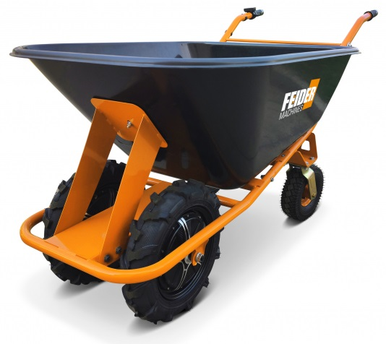

ELECTRIC WHEELBARROW

**NEXO4B-24V**

## USER GUIDE

CAUTION: Read this manual before using this machine!

**CONTENTS**

1. **TECHNICS 3**
2. **SAFETY INSTRUCTIONS 5**
3. **ASSEMBLY 7**
4. **OPERATION 11**
5. **MAINTENANCE AND STORAGE 14**
6. **TROUBLE SHOOTING 15**
7. **SPARE PARTS 15**
8. **DISPOSAL 16**
9. **DECLARATION OF CONFORMITY 17**
10. **WARRANTY 18**
11. **PRODUCT FAILURE 19**
12. **WARRANTY EXCLUSIONS 20**

**1. TECHNICS**

**1.1 Components**

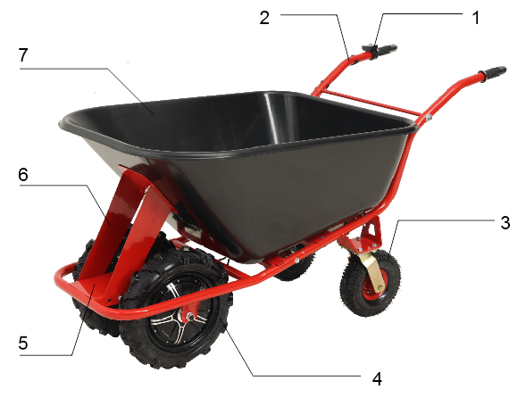

|  |  |  |  |
| --- | --- | --- | --- |
| **NEXO4B-24V** | | | |
| **1** | Speed Control lever | **5** | Front Tubular Frame |
| **2** | Handle Assy | **6** | Front Tray support |
| **3** | Universal wheel | **7** | Tray |
| **4** | Front wheel with motor(left) |  |  |

**1.2 Technical data**

|  |  |
| --- | --- |
| **NEXO4B-24V** | |
| Rated voltage | 24V |
| Battery capacity | 12 Ah |
| Max Battery worktime [h] | 5 h |
| Motor power | 1000W (2*500 W) |
| speed | max.forward 6 km/h, reverse 2 km/h |
| max. load capacity | 300kg |
| weight (netto/net) | 58 kg |
| Dimension | 1660x880x920 m |
|  |  |
| Charger: |  |
| Input voltage | 220-240 V~ / 50 Hz |
| Power | 65 W |
| Output | 29.6 V 1.6-1.8A |
| Charge time | 6 h |
| Protection class | II |
| Battery: | YH2412Q Lead acid battery |
| Rated voltage | 24 V |
| Battery capacity | 12 Ah |
| Battery power | 288Wh |
| Weight | 11kg |
| Dimension | 151x99x97 mm |

**1.3 SYMBOLS**

|  |  |
| --- | --- |
|  | Conforms to relevant safety standards. |
|  | To reduce the risk of injury, the user must read and understand this manual before using this product. |
|  | Do not dispose of old appliances with domestic rubbish. |
|  | Class II, double isolation (only for charger). |
|  | Battery and charger to be used indoors only. |
|  | Type of Connection. |
|  | Warning! Prohibit high-pressure water gun flushing. |
|  | Wear foot protection! |

**2. SAFETY INSTRUCTIONS**

**2.1 Intended use**

The machine must only be used for its intended purpose! Any use other than listed in this manual is deemed misuse. To use the machine properly you must observe and follow all safety regulations, the assembly instructions, operating and maintenance instructions described in this manual.

All users of the machine must be acquainted with this manual and must be informed about the machine's potential hazards.

The machine is used for transportation of goods within the maximum permissible load capacity.

**Speed Barrow and its sales partners cannot be held liable for any direct or indirect damage caused by manipulation or misuse of the machine and or its parts.**

|  |  |
| --- | --- |
| **WARNING** | |
|  | **· The removal or modification of the safety components may result in damage to equipment and serious injury!**  **HIGHEST RISK OF INJURY!** |

**Ambient conditions**

The machine should be operated:

|  |  |
| --- | --- |
| humidity | 0% to 70% |
| temperature | 0°С to 40°С (32°F to 104°F) |

The machine, especially the battery may not be exposed to a temperature of greater than 40°C.

**Prohibited use:**

* The operation of the machine outside the technical limits described in this manual is prohibited.
* The operation of the machine without protective devices is prohibited.
* Using the machine for unintended use other than what it is designed and outlined in this manual is prohibited.
* Any manipulation of the machine and parts is prohibited.

**2.2 Security instructions**

Missing or non-readable security stickers should be replaced immediately!

The locally applicable laws and regulations may specify the minimum age of the operator and limit the use of this machine!

To avoid malfunction, machine defects and injuries, read the following security instructions:

**GENERAL:**

* Use the machine only in good enough light to allow visibility and safe operation.
* Use of the machine is prohibited during episodes of exhaustion, decreased concentration or under the influence of alcohol or drugs.
* Caution in slippery conditions! Slip hazard-risk of injury. When operating the machine, it is suggested to wear non-slip footwear.
* The machine must be operated by trained personnel.
* Use both hands while operating the machine.
* The instruction manual must stay with the machine, and must be given to the third party if transferred.
* A safety check must be performed on the machine before each use.
* Take caution when operating the machine near pools, ponds or any body of water.
* The machine should not be operated in rain, damp or wet areas.
* Unplug the battery before changing any settings or performing any maintenance.

**CHARGER:**

* The charger is designed exclusively to charge the battery of this machine. Charging other batteries is not permitted.
* Never use the charger in a damp or wet environment.
* Disconnect the cable connection only by pulling the plug, pulling the cable could damage the cable and plug. Electrical safety would no longer be guaranteed.
* Never use the charger if the cord, plug or the appliance itself is damaged. Do not use the unit near heat sources.
* Do not use an extension cord to supply power to the charging station.
* Do not place metal objects in the area of the charging contacts on the charger.
* Do not open the charger. In case of failure, contact a specialist.
* Recharge your battery only with the original charger. Use of other chargers may cause defects to the battery or a fire hazard.

**BATTERY:**

* Improper use of the battery or the use of damaged batteries can cause vapor leaking to occur, leave the working area, if inside go outside and seek medical attention if required.
* FIRE HAZARD! Never charge batteries near acids and flammable materials.
* Charge the battery only in temperatures between 0°C to 40°C. Once charged, leave to cool down.
* EXPLOSIVE! Protect the battery from heat and fire.
* Use the battery only in temperatures between 0 ° C to 40 ° C.
* SHORT CIRCUIT! The items must be packaged and taped for disposal, transport or storage of the battery and the contacts.
* Never open the battery.

**2.3 Remaining risk factors**

Despite the intended use, certain residual risks remain. Due to the design and construction of the machine, hazardous situations may occur which are identified as follows in these operating instructions:

|  |  |
| --- | --- |
| **DANGER** | |
|  | A safety instruction designed in this way indicates an imminently hazardous situation which, if not avoided, will result in death or serious injury. |

|  |  |
| --- | --- |
| **WARNING** | |
|  | Such a safety instruction indicates a potentially hazardous situation which, if not avoided, may result in serious injury or even death. |

|  |  |
| --- | --- |
| **CAUTION** | |
|  | A safety instruction designed in this way indicates a potentially hazardous situation which, if not avoided, may result in minor or moderate injury. |

|  |  |
| --- | --- |
| **NOTICE** | |
|  | A safety note designed in this way indicates a potentially dangerous situation which, if not avoided, may result in property damage. |

Irrespective of all safety regulations, your common sense and your corresponding technical suitability/training are and will remain the most important safety factor for error-free operation of the machine. **Safe working depends first and foremost on you!**

**3. ASSEMBLY**

Please check the product contents immediately after receipt for any eventual transport damage or missing parts. Claims from transport damage or missing parts must be placed immediately after initial machine receipt and unpacking before putting the machine into operation. Please understand that later claims cannot be accepted.

|  |  |
| --- | --- |
| **NOTICE** | |
|  | Don't fully tighten all screws until assembly is complete. |

**3.1 Assembly-steps**

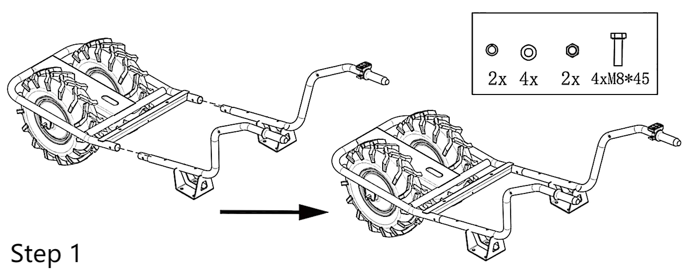

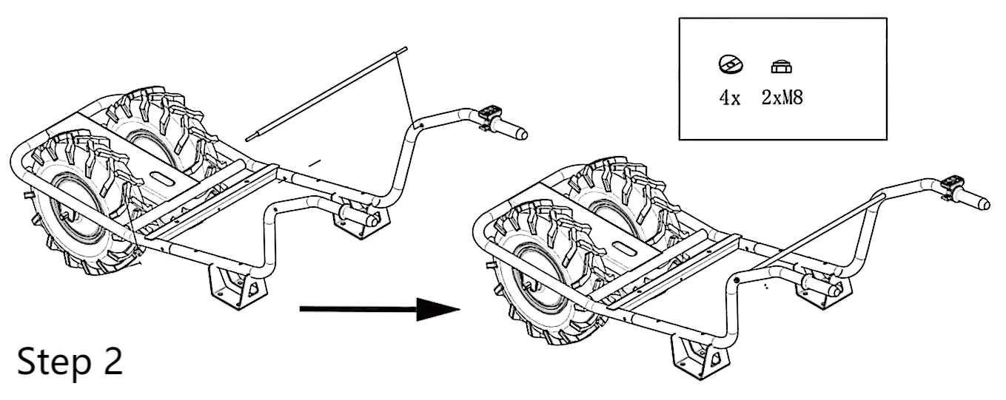

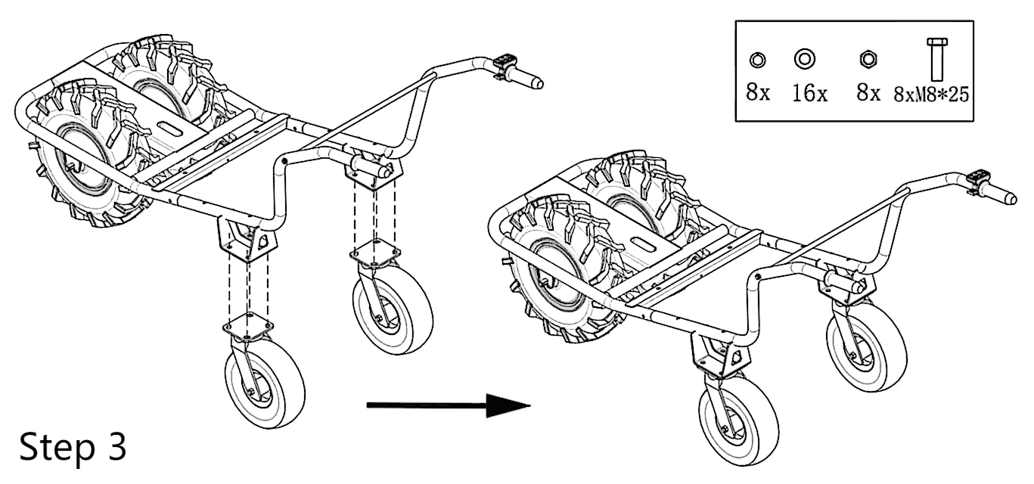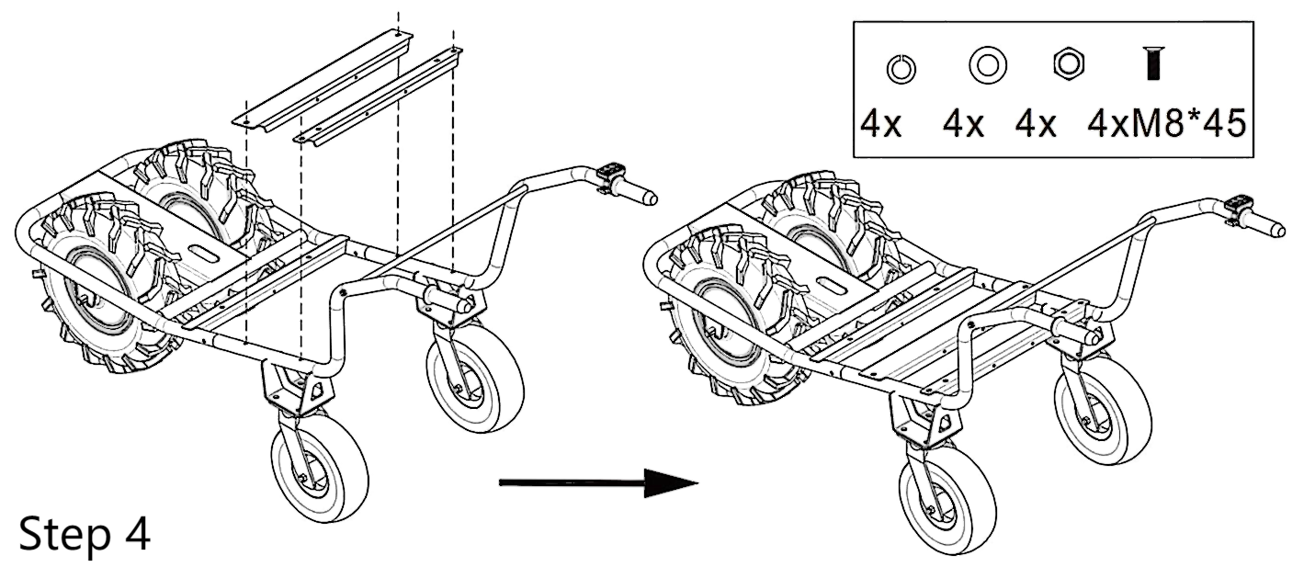

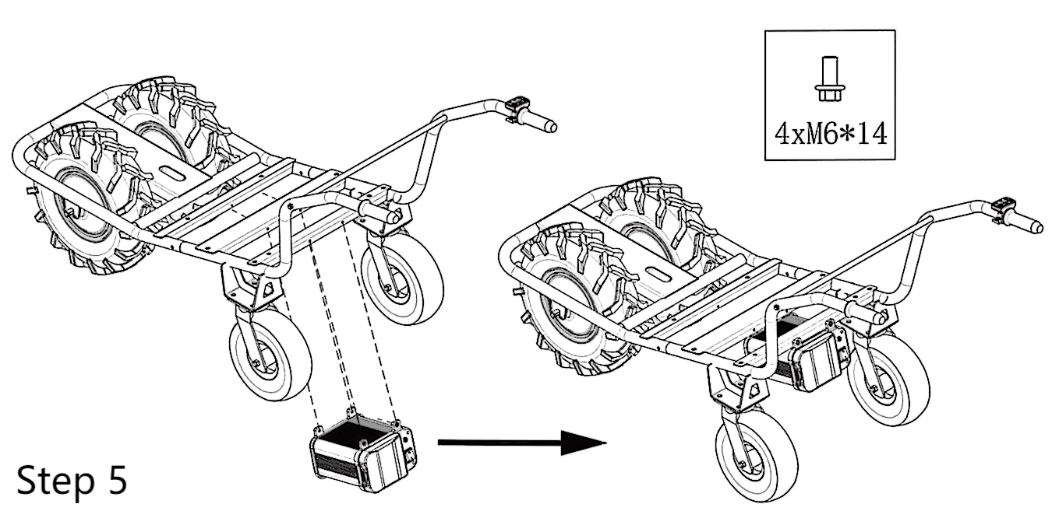

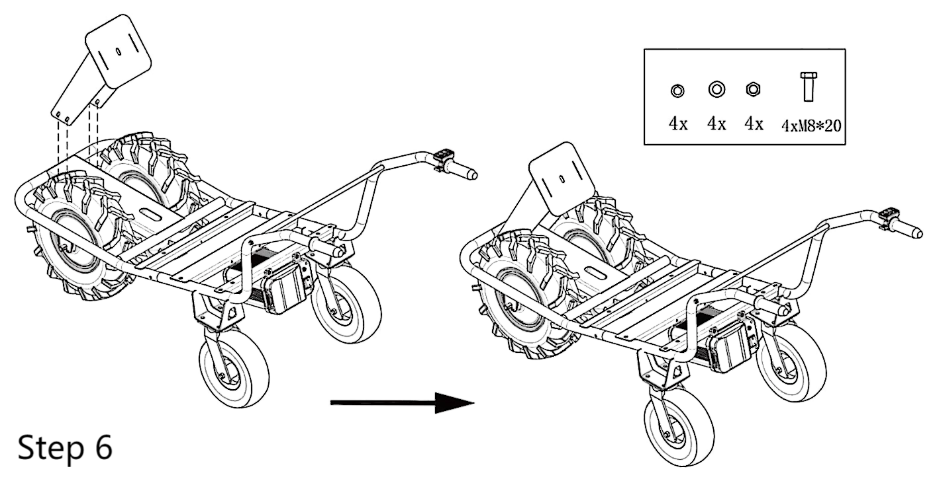

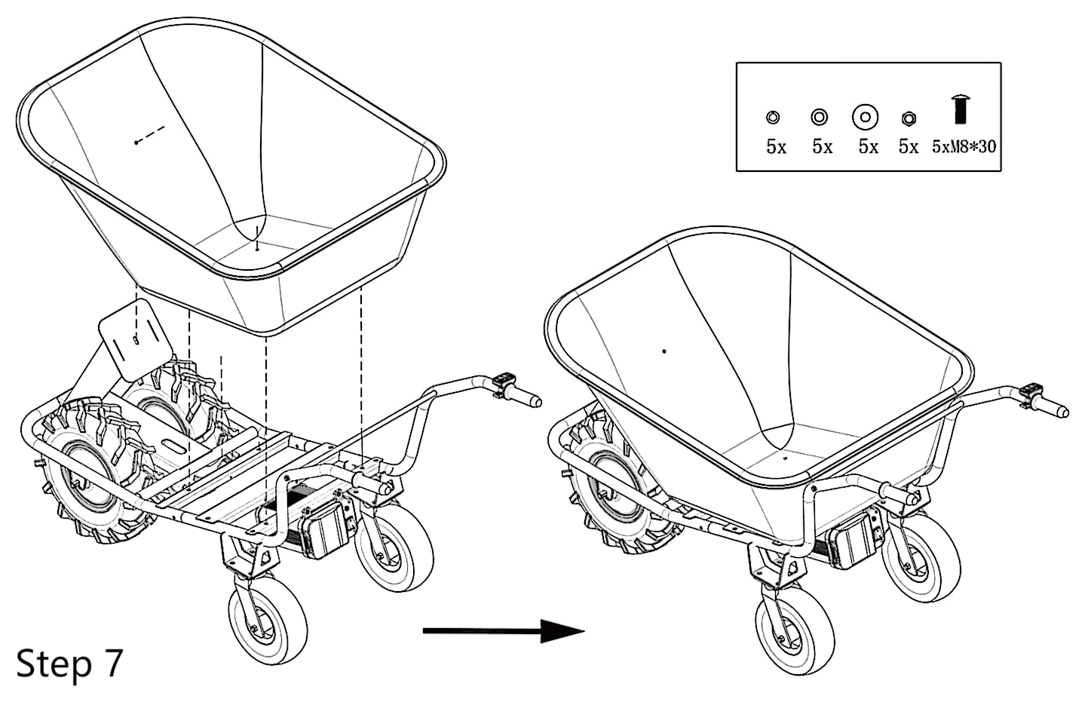

**3.2 Assembly-steps for cable**

3.2.1 Connect control lever cable （6pin plug&socket）

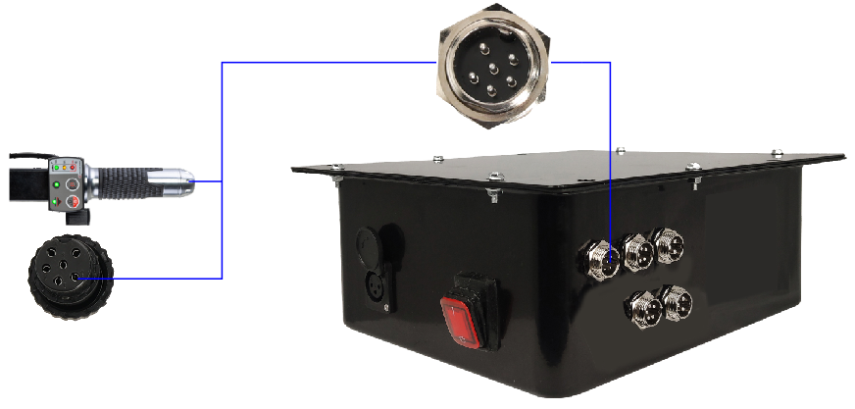

3.2.2 Connect motor cable（3&5 pin plug&socket）

Firstly make sure the motor are in the right position, the motor cable is at the inner side

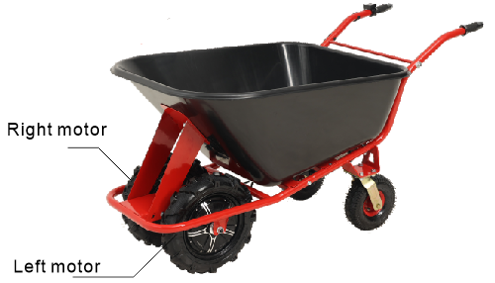

Then connect the cable

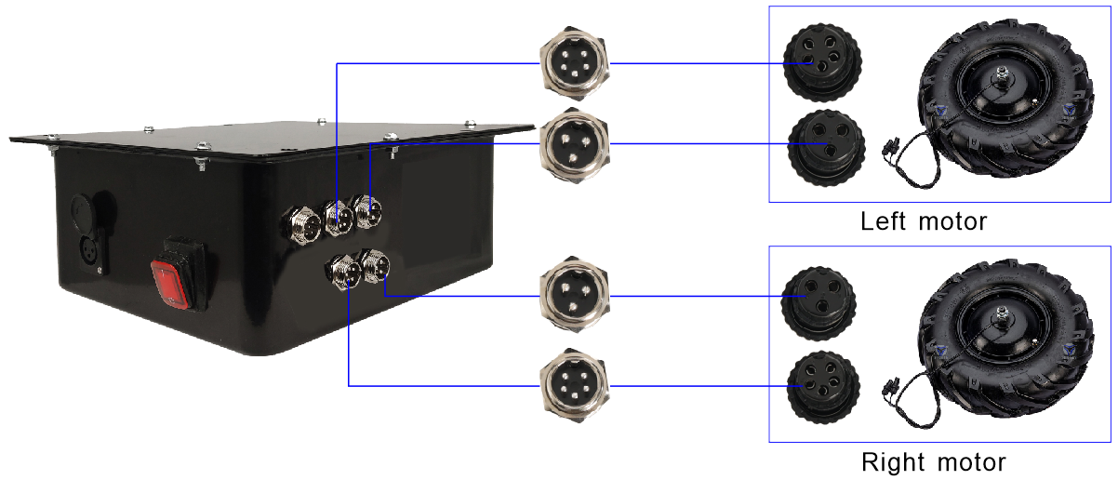

**Warning:** Only nut #1 is allowed to be turned in order to fasten or unfasten the plug, nut #2 is prohibited to be turned otherwise for professional repair.

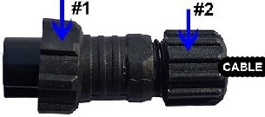

**4. OPERATION**

The machine must be operated in a perfect state only. Inspect the machine visually every time it is to be used. Check in particular the safety equipment, electrical controls, electric cables and screwed connection for damage and if tightened properly. Replace any damaged parts before operating the device.

**4.1 Operation instructions**

|  |  |
| --- | --- |
| **WARNING** | |
|  | **Unplug battery before all maintenance and settings!** |

|  |  |
| --- | --- |
| **NOTICE** | |
|  | **· Never remove the battery while the machine is running.**  **· In case of longer standstill, press the shut-down button.**  **· Use the electric motor only with sufficient battery charge.** |

**4.2 Operation**

**4.2.1 Start electrical support**

|  |  |
| --- | --- |
|  | * Press the power button on the battery box to "1:=ON". |
|  | * 1. light #L1(green), #L3(green) * 2. press the throttle lever #1, the wheelbarrow will go forward * 3. if press button #2 once, light #L2 on, press throttle lever #1, the wheelbarrow will go backwards * 4. if press butter #3, then light #L3 will turn red, the EBS brake gets activated, the wheelbarrow won’t move even pressing throttle lever #1. Press the button #3 again, the EBS will get deactivated |
|  | When the throttle lever #1 is activated, the battery charge level is displayed as follows:  -- All 3 LEDs green & orange & red light up:  Battery charge level between 100-50%  -- Only 2 LEDs orange & red light up:  Battery charge level between 50-10%  -- Only the red LED lights up:  Please charge the battery |

**Electronic Brake System:** This wheelbarrow is equipped with electronic brake EBS/BAS

|  |  |
| --- | --- |
| **BAS ON** | The BAS will work only when   * Button on the battery box is "1:=ON". * Thumb switch #1 is at its original position, no acceleration. |
| **EBS ON** | The EBS will work only when   * Button on the battery box is "1:=ON". * Brake switch #3 at “1” position. |

**Notice:**

* When EBS is ON, the wheelbarrow will be stopped completely. Even if the thumb switch is pressed, the wheelbarrow will not move.
* When BAS is on, the wheelbarrow will be stopped on the flat ground, however if on a downward slope it may move slowly.
* BAS will not affect the battery power, however EBS will. It is recommended to use BAS most of the time.
* The two above brake systems will provide convenience and safety while the wheelbarrow is on the slope or dumping the goods.

**4.2.2 On the slope**

For safety reason, never overload at any conditions, meanwhile please operate within the limit of the below requirement.

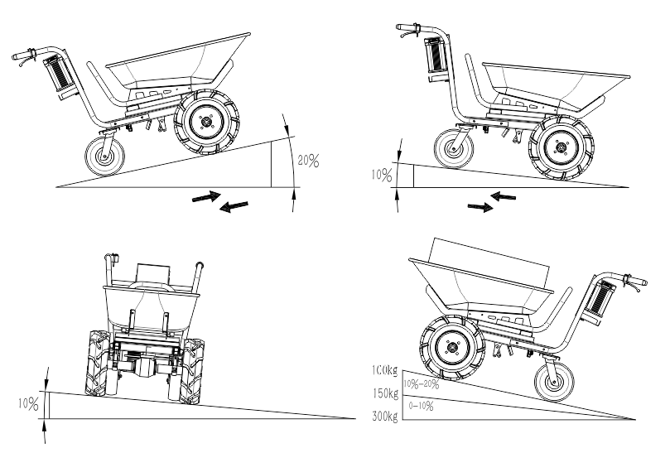

**4.3 Charger**

Charger is integrated in the battery system (#7).

**Charging the battery:**

* Connect the charger to the power supply (AC outlet) 230 V / 50 Hz and the charger plug.
* Charge the battery.
* Once the battery is fully charged (indication on the charger)， the light on the charger will turn red to green, then the charger can be removed.

- Light red: charging

- Light green: battery full

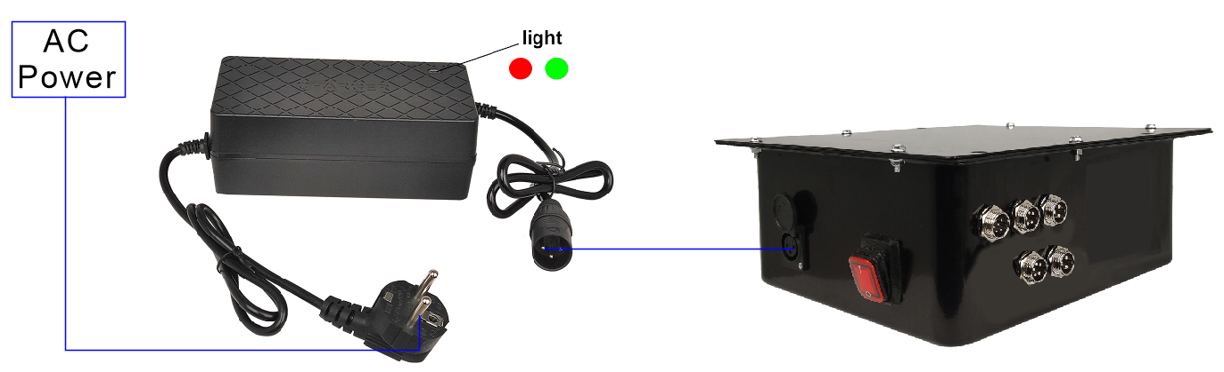

**5. MAINTENANCE AND STORAGE**

|  |  |
| --- | --- |
| **ATTENTION** | |
|  | **Unplug battery before all maintenance and settings!**  **Serious injury due to unintentional or automatic activation of the machine!** |

The machine does not require extensive maintenance. If malfunctions and defects occur, it must be serviced by trained persons only.

|  |
| --- |
| **NOTICE** |
| Clean your machine regularly after every use – this will prolong the machines lifespan and is a pre-requisite for a safe working environment. |

Check regularly the condition of the security stickers. Replace them if required and ensure they are always visible.

Check regularly the condition of the machine.

Store the machine in a closed, dry location after each time use.

**5.1 Maintenance plan**

**After each work shift:**

* Check the cables to ensure a tight fit and no damage has occurred.

**5.2 Cleaning**

|  |
| --- |
| **NOTICE** |
| **The usage of certain solutions containing ingredients damaging metal surfaces as well as the use of scrubbing agents will damage the machine surface!**   * Clean the machine surface with a wet cloth each time use.   **Never use high pressure cleaner to clean the machine.** |

* Clean the outer parts with a damp sponge.
* Never clean the electronic parts with water!
* Check the machine and remove the deposits and/or residues with a brush after each use.

**5.3 Storage**

* Clean thoroughly all components before storage.
* Store all components separately in a dry area no less than -10 ° C.
* Charge the battery fully before storing.

|  |
| --- |
| **NOTICE** |
| During longer standstill and at least after one month charge the battery. |

**6. TROUBLE SHOOTING**

**BEFORE YOU START WORKING FOR THE ELIMINATION OF DEFECTS, UNPLUG THE BATTERY.**

|  |  |  |
| --- | --- | --- |
| **Problem** | **Possible cause** | **Solution** |
| **No electrical support** | Battery is not charged | Recharge battery |
| Motor stuck | Check motor |
| Power switch is damaged | Check switch |
| Broken or loose cables | Check cables |
| **No charging of battery** | Loosen cable | Check cable connection |

**7. SPARE PARTS**

**The installation of parts other than the original parts voids the warranty!**

When you place a spare parts order, please always take note of the machine type, spare part number and part name. We recommend to copy the spare parts diagram below and mark the spare part you need.

**7.1 Exploded view**

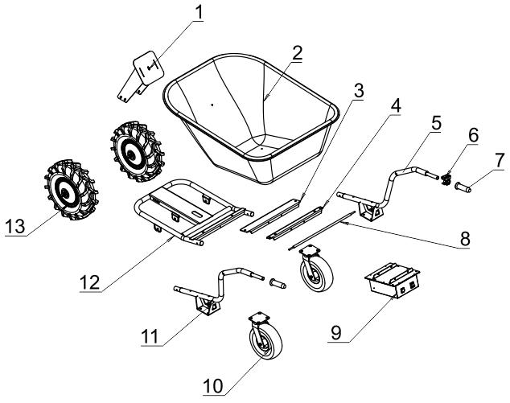

|  |  |  |
| --- | --- | --- |
| **NO.** | **PART NAME** | **QTY** |
| 1 | Front Tray support | 1 |
| 2 | Tray | 1 |
| 3 | front reinforce rib | 1 |
| 4 | back reinforce rib | 1 |
| 5 | right handle | 1 |
| 6 | speed control lever | 1 |
| 7 | handle grip | 1 |
| 8 | reinforced bar | 1 |
| 9 | battery assy | 1 |
| 10 | Universal wheel | 2 |
| 11 | left handle | 1 |
| 12 | front tubular frame | 1 |
| 13 | Motor with wheel | 2 |

**8. Disposal**

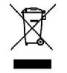Do not dispose of the machine and the battery in residential waste. Contact your local authorities for information regarding the available disposal options. When purchasing at your local dealer for a replacement unit, the latter is obliged to exchange your old machine.

**9. DECLARATION OF CONFORMITY**



BUILDER SAS

32 rue Aristide Bergès - Z.I. du Casque - 31270 Cugnaux - France

Tel: +33 (0) 5.34.508.508 Fax: +33 (0) 5.34.508.509

Declare that the machine designated below

ELECTRICAL WHEELBARROW

NEXO4B-24V

Serial number: 20230705441-20230705488

Conforms to the provisions of the Machinery Directive 2006/42 / EC and the national regulations transposing it;

Also complies with the provisions of the following European directives:

To the EMC Directive 2014/30 / EU

To the ROHS Directive: (EU)2015/863 amending 2011/65/EU

Also complies with European standards, national standards and the following technical provisions:

EN 60204-1: 2018

EN ISO12100: 2010

EN IEC61000-6-1:2019

EN 61000-6-3:2007+A1:2011+AC:2012

EN IEC61000-3-2: 2019

EN 61000-3-3: 2013+A1:2019

Responsible of technical file: Olivier Patriarca

Cugnaux, 26/06/2023

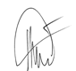

Philippe MARIE / PDG



 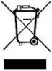

BUILDER SAS

32 rue Aristide Bergès - Z.I. du Casque - 31270 Cugnaux - France

Made in PRC